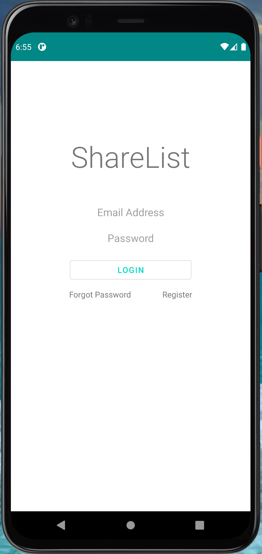

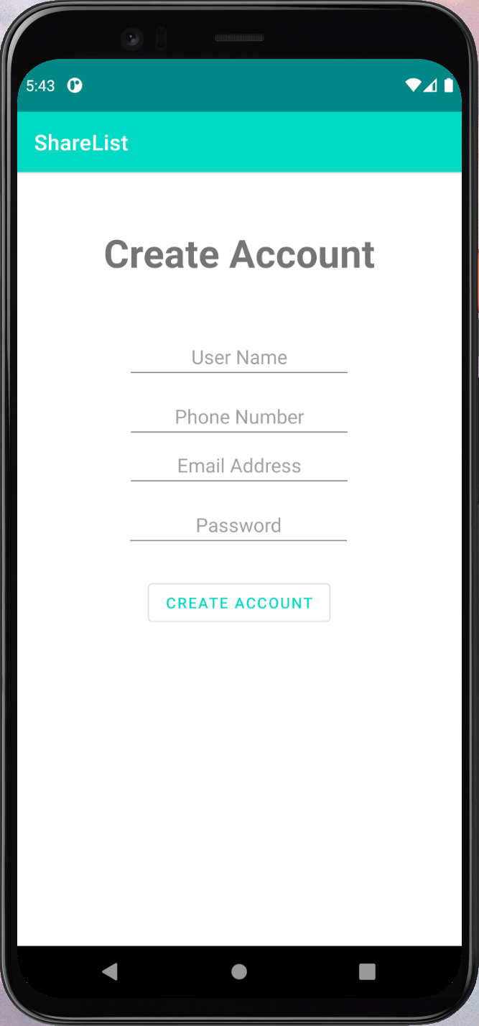

|  |  |
| --- | --- |
| EUC1.1: Register |  |
| ***Precondition:*** *This use case assumes that the user is seeing the Login Activity page.* | |
| Actor: User | System: ShareList/LoginMGMT |
| 1. TUCBW the user clicks on the 'Register' button.  3. User enters credentials and clicks 'Create Account'.  5. TUCEW the new user is registered successfully. | 0. System displays the Login page.  2. System displays the Register Activity page.  *4. System checks if the information is okay, displays a confirmation, and takes the user back to the Login page. |
| ***Postcondition:*** *The user's new account is stored in the database, ready for authentication.* | |



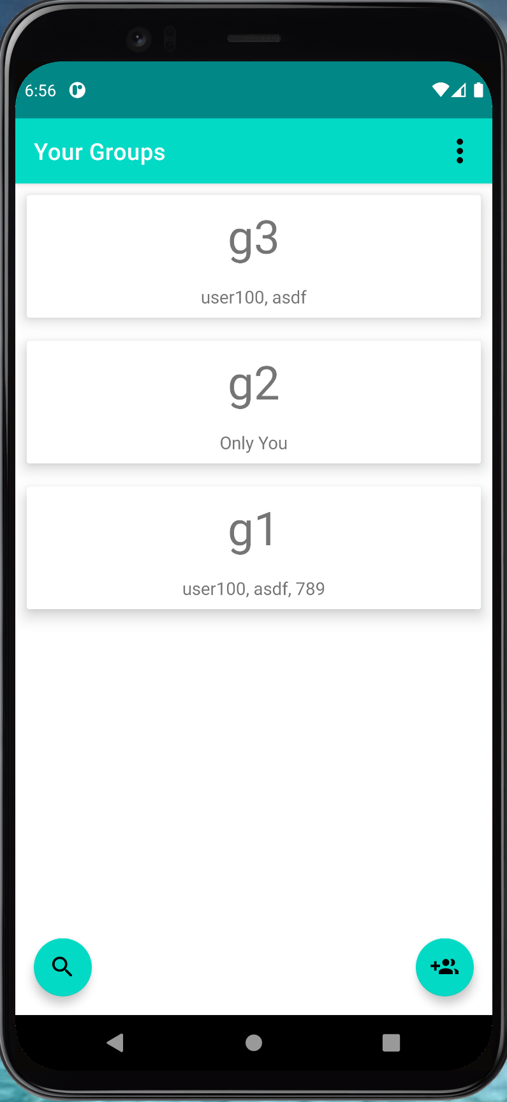

|  |  |
| --- | --- |
| EUC1.2: Login |  |
| ***Precondition:*** *This use case assumes that the user is seeing the Login page and is a registered user.* | |
| Actor: User | System: ShareList/LoginMGMT |
| 1. TUCBW the user enters their details and clicks on the Login button.  3. TUCEW the user successfully logs in. | 0. System displays the Login page.  *2. System checks the credentials entered by user:  a) If the credentials are correct, the users 'Your Groups' page will be displayed.  b) If incorrect, the system will display an “Incorrect email or password!” message. |
| ***Postcondition:*** *The user will be able to access the features of the app.* | |

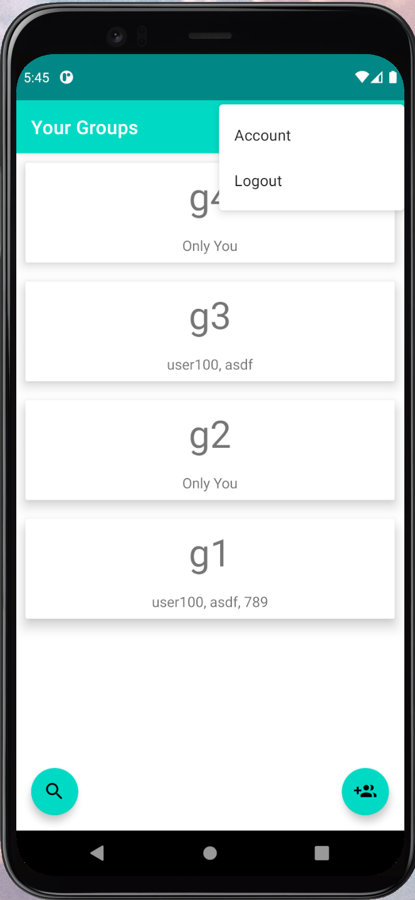



|  |  |
| --- | --- |
| EUC1.3: Log Off |  |
| ***Precondition:*** *This use case requires that the user is logged in and is on the Your Groups page.* | |
| Actor: User | System: ShareList/LoginMGMT |
| 1. TUCBW user clicks on the Logout button.  3. TUCEW user successfully logs out of the application. | 0. System displays the Logout button on the corner menu.  2. System displays the Login/Register page. |
| ***Postcondition:*** *The user must be able to login again.* | |



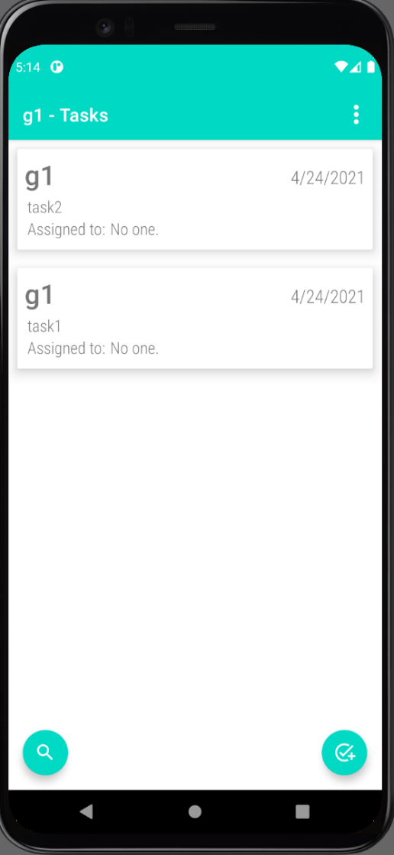

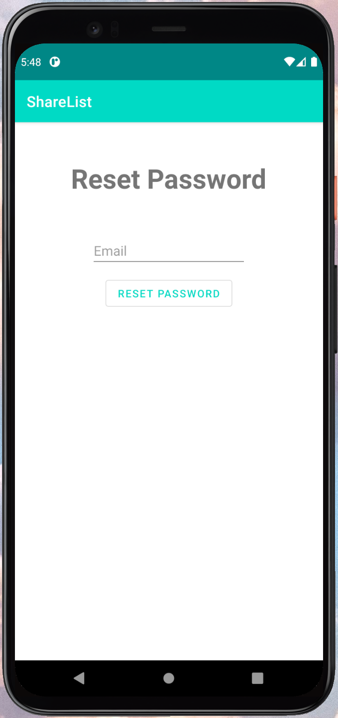

|  |  |
| --- | --- |
| EUC1.4: Reset Password |  |
| ***Precondition:*** *This use case requires that the user is already registered.* | |
| Actor: User | System: ShareList/LoginMGMT |
| 1. TUCBW user clicks on the Forgot Password button.  3. The user enters the email id and clicks on the Reset Password button.  5. The user clicks on the link received in email and enters the new password.  7. TUCEW the password of the user is changed. | 0. System displays the Login/Register page.  2. System prompts the user to enter the registered email id.  4. System sends a link to the email to reset the password.  6. System successfully updates the new password. |
| ***Postcondition:*** *The user's new password is stored in the database.* | |

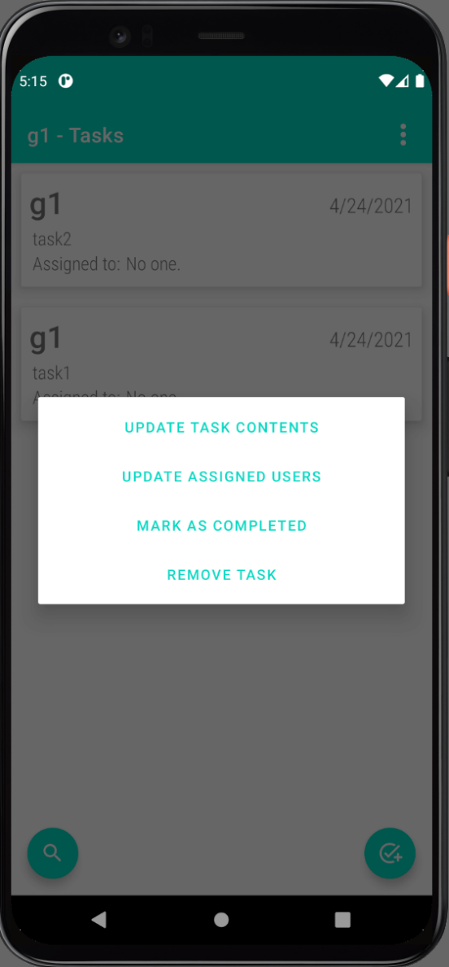

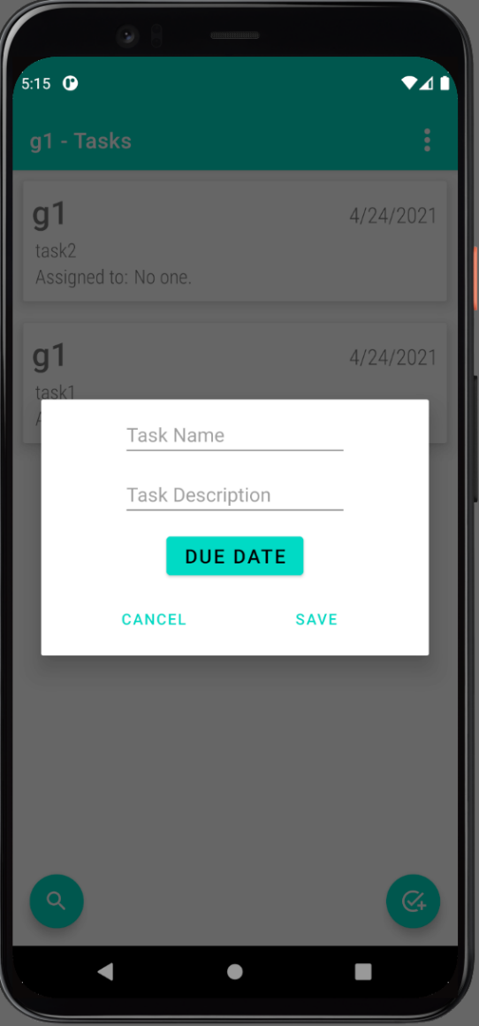

|  |  |
| --- | --- |
| EUC2.1: Add Tasks |  |
| ***Precondition:*** *This use case requires that the user is logged in and is an admin of the group.* | |
| Actor: Group Admin | System: ShareList/ManageTask |
| 1. TUCBW group admin clicks on the Add Task button.  3. The group admin enters the information and clicks on the Save button.  5. TUCEW the group admin sees a confirmation “The task has been added” on the app | 0. System displays the Add task button.  2. System prompts the group admin to enter the Task name, Task Description and Due date.  *4. System checks for errors and processes the save request. |
| ***Postcondition:*** *The task is stored in the database.* | |



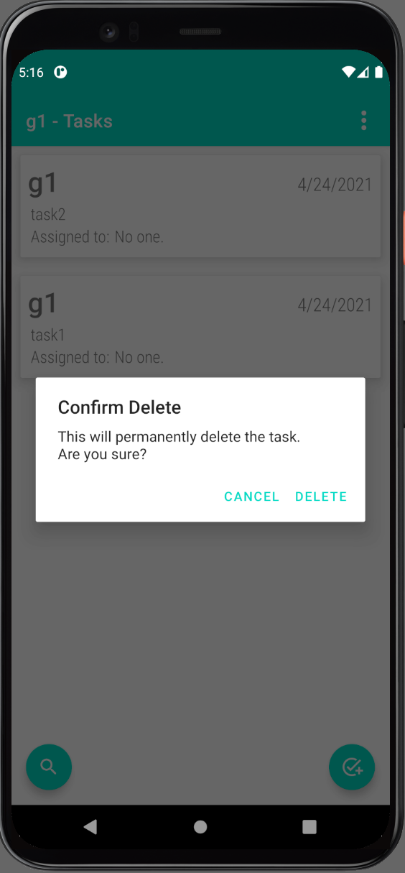

|  |  |
| --- | --- |
| EUC2.2: Remove Tasks |  |
| ***Precondition:*** *This use case requires that the user is an admin of the group and the task has been created.* | |
| Actor: Group Admin | System: ShareList/ManageTask |
| 1. TUCBW group admin clicks on the Remove task button.  3. The group admin confirms by clicking the “Confirm” button.  5. TUCEW the group admin sees a confirmation of the task being removed. | 0. System displays the Remove task button.  2. System prompts the group admin to confirm the remove task activity.  *4. System removes the task. |
| ***Postcondition:*** *The task is removed in the database.* | |

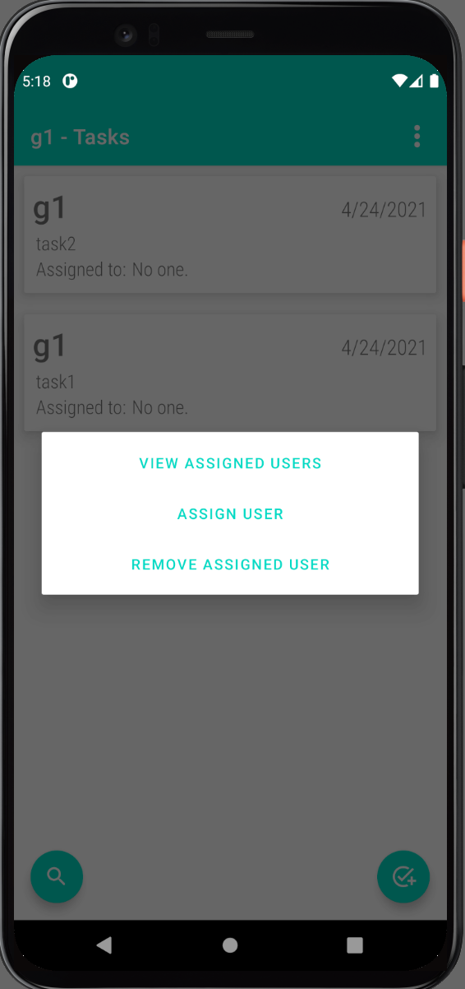

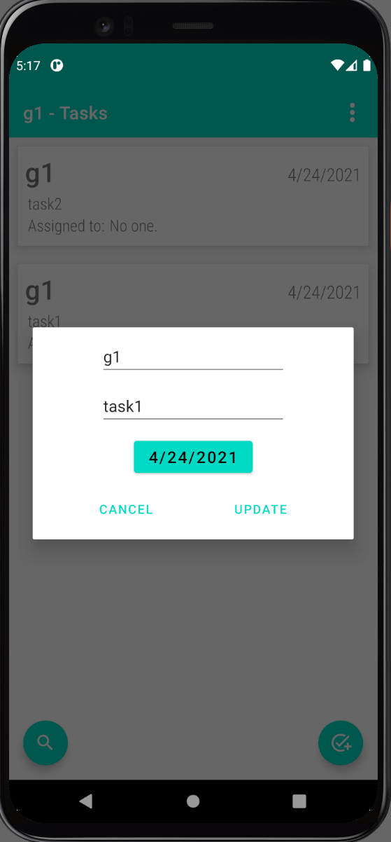

|  |  |
| --- | --- |
| EUC2.3: Edit Tasks |  |
| ***Precondition:*** *This use case requires that the task is already created.* | |
| Actor: Group Admin | System: ShareList/ManageTask |
| 1. TUCBW group admin clicks on the ‘Update Task Contents’ button.  3. TUCEW group admin sees the changes. | 0. System displays the Update Task Contents button.  *2. System provides the group admin the ability to edit name, description, due date and displays a message “The task has been updated”. |
| ***Postcondition:*** *The task is edited successfully and updated in the database.* | |

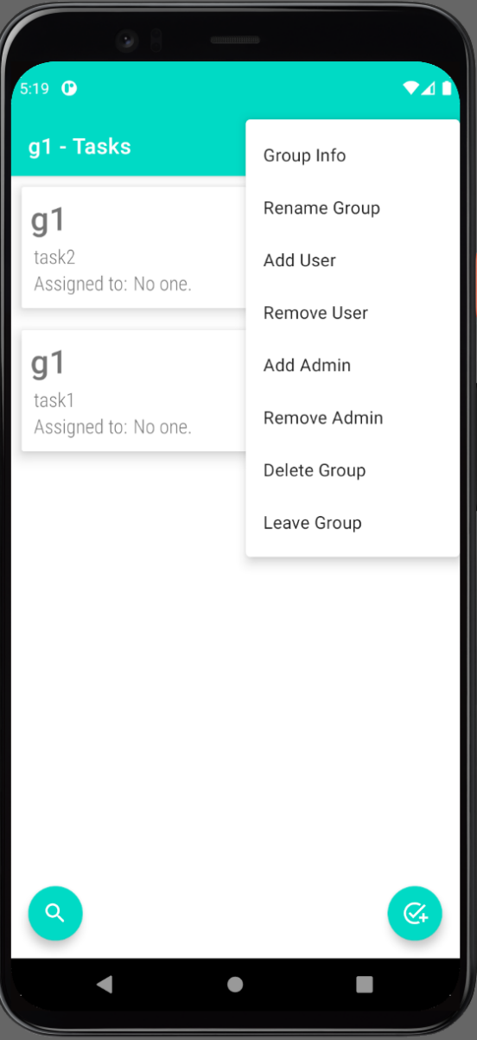

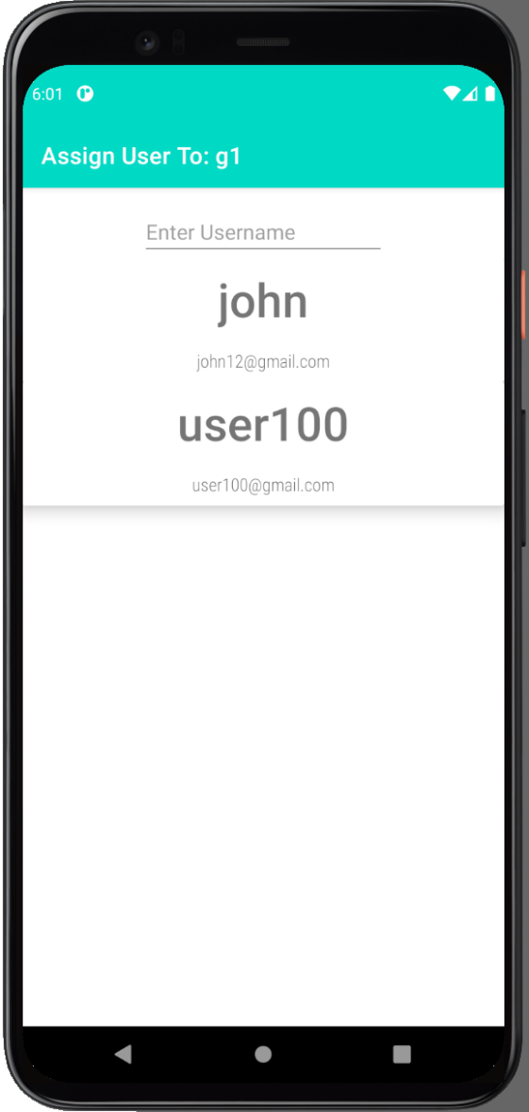

|  |  |
| --- | --- |
| EUC2.4: Assign Tasks |  |
| ***Precondition:*** *This use case requires that the user is an admin of the group and the task is created.* | |
| Actor: Group Admin | System: ShareList/ManageTask |
| 1. TUCBW the group admin clicks on the Assign User button.  3. The group admin selects the user to assign.  5. TUCEW group admin sees the user is assigned to the task. | 0. The system displays options: View Assigned Users, Assign User and Remove Assigned Users  2. System allows the group admin to choose the user to assign the task.  *4. System assigns the selected user. |
| ***Postcondition:*** *The task is assigned to the respective user successfully.* | |

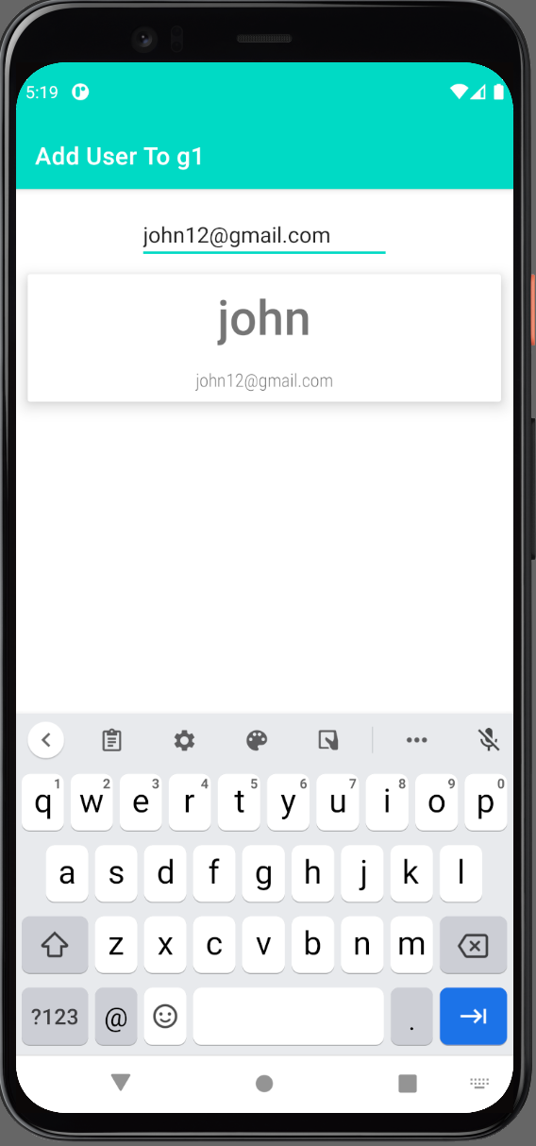



|  |  |
| --- | --- |
| EUC3.1: Add Users |  |
| ***Precondition:*** *This use case requires that the user is an admin of the group.* | |
| Actor: Group Admin | System: ShareList/ManageGroup |
| 1. TUCBW admin clicks on the ‘Add User’ button.  3. Group admin selects the user to be added.  5. TUCEW group admin sees the user added to the group. | 0. System displays the Add User button.  2. System prompts admin to enter the user's email to be added.  *4. System adds the user and displays a message “User has been added.” |
| ***Postcondition:*** *The user is successfully added to the respective group.* | |

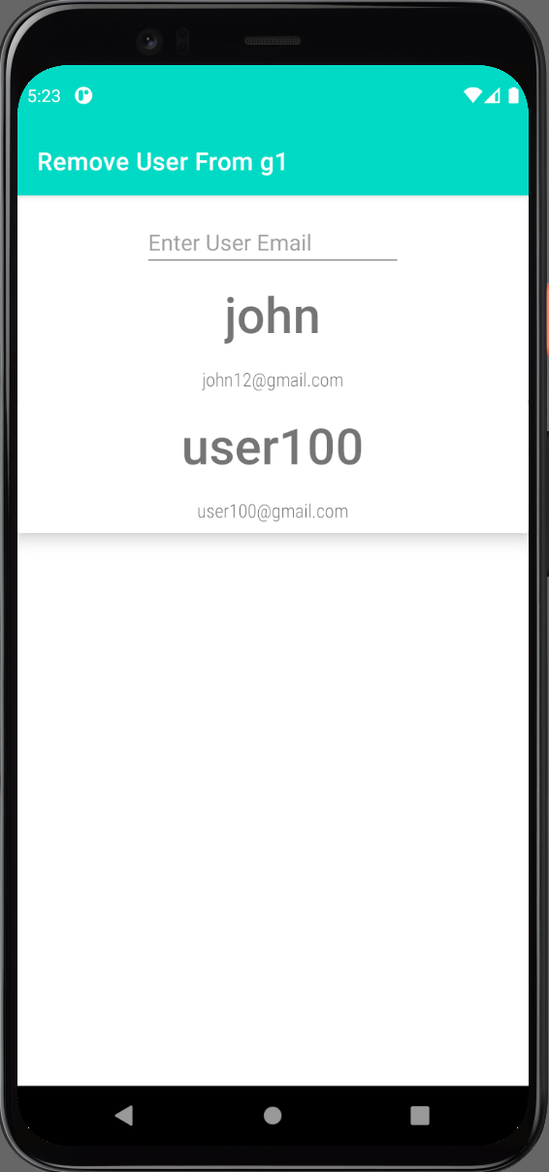

|  |  |
| --- | --- |
| EUC3.2: Remove users |  |
| ***Precondition:*** *This use case requires that the user is an admin of the group.* | |
| Actor: Group Admin | System: ShareList/ManageGroup |
| 1. TUCBW admin clicks on the Remove User button.  3. Group admin selects the user to be removed.  5. TUCEW group admin sees the user is no longer a member of the group. | 0.System displays the Remove User button.  *2.System prompts admin to enter the user's email to be removed.  4. System displays message to confirm the removal of the user. |
| ***Postcondition:*** *The selected user is successfully removed from the respective group.* | |

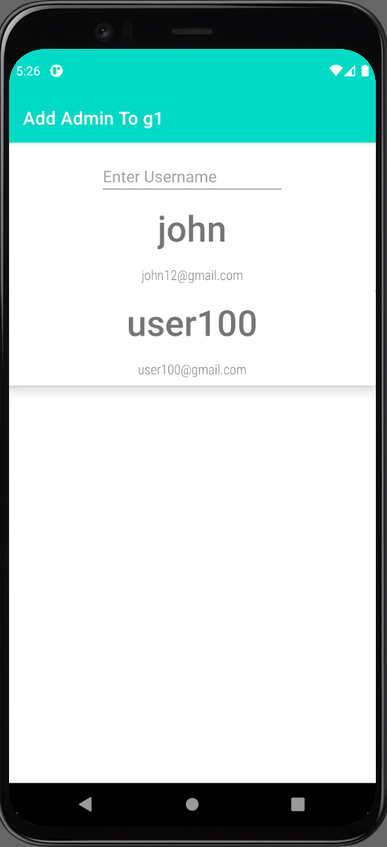

|  |  |
| --- | --- |
| EUC3.3: Add Admins |  |
| ***Precondition:*** *This use case requires that the user is an admin of the group.* | |
| Actor: Group Admin | System: ShareList/ManageGroup |
| 1. TUCBW group admin clicks on the ‘Add Admin’ button.  3. TUCEW group admin sees the user is now an admin. | 0. System displays the Add Admin button.  *2. System prompts admin to select another user to be added as an admin. |
| ***Postcondition:*** *The user is successfully added as the admin of the respective group, and the database is updated to reflect this change.* | |

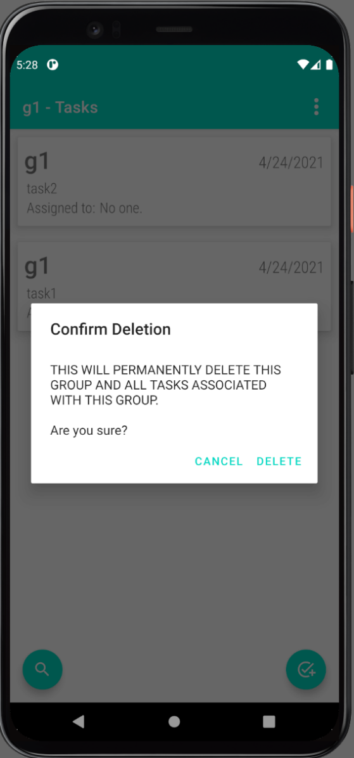

|  |  |
| --- | --- |
| EUC3.4: Delete Group |  |
| ***Precondition:*** *This use case requires that the user is an admin of the group and the group is created.* | |
| Actor: Group Admin | System: ShareList/ManageGroup |
| 1. TUCBW group admin clicks on the Delete group button.  3. Group admin selects Delete.    5. TUCEW the group, related tasks and users, are removed from the records. | 0. System displays the Delete group button.  2. System asks the group admin for confirmation.  *4. System deletes the group. |
| ***Postcondition:*** *The group is deleted successfully, and the entry is removed from the database.* | |



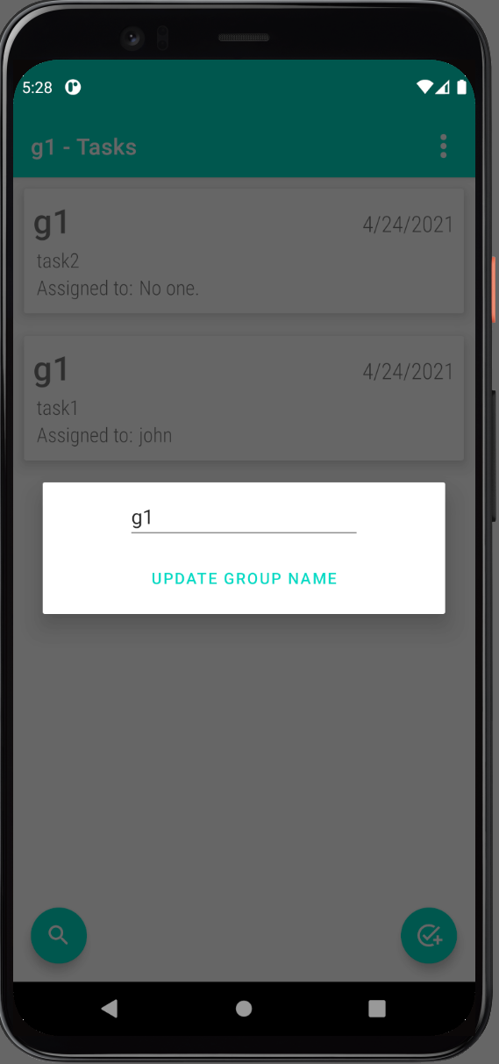

|  |  |
| --- | --- |
| EUC3.5: Edit Group |  |
| ***Precondition:*** *This use case requires that the user is an admin of the group and the group is created.* | |
| Actor: Group Admin | System: ShareList/ManageGroup |
| 1. TUCBW admin clicks on the ‘Rename Group’ button.  3. TUCEW group admin sees that the group name is updated. | 0. System displays the Rename Group button.  *2. System provides an option to edit the group name. |
| ***Postcondition:*** *The group name is updated successfully, and database reflects these changes.* | |



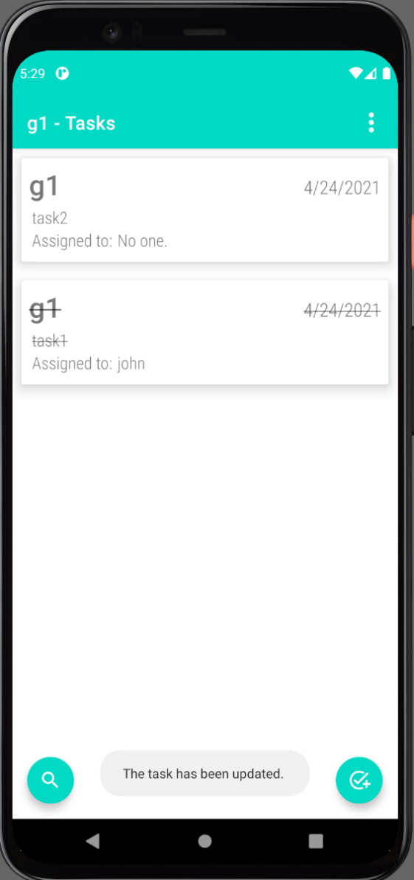

|  |  |
| --- | --- |
| EUC4: Mark Task as Completed |  |
| ***Precondition:*** *This use case requires that the user is a member of the group and the task is not marked as complete.* | |
| Actor: User | System: ShareList/ManageTask |
| 1. TUCBW user clicks on the ‘Mark Task as Completed’ button.  3. TUCEW the user sees the task as crossed off. | 0. System displays the ‘Mark Task as Completed’ button.  *2. System displays a message “The task has been updated”. |
| ***Postcondition:*** *The task is marked as completed, and its status updated in the database.* | |

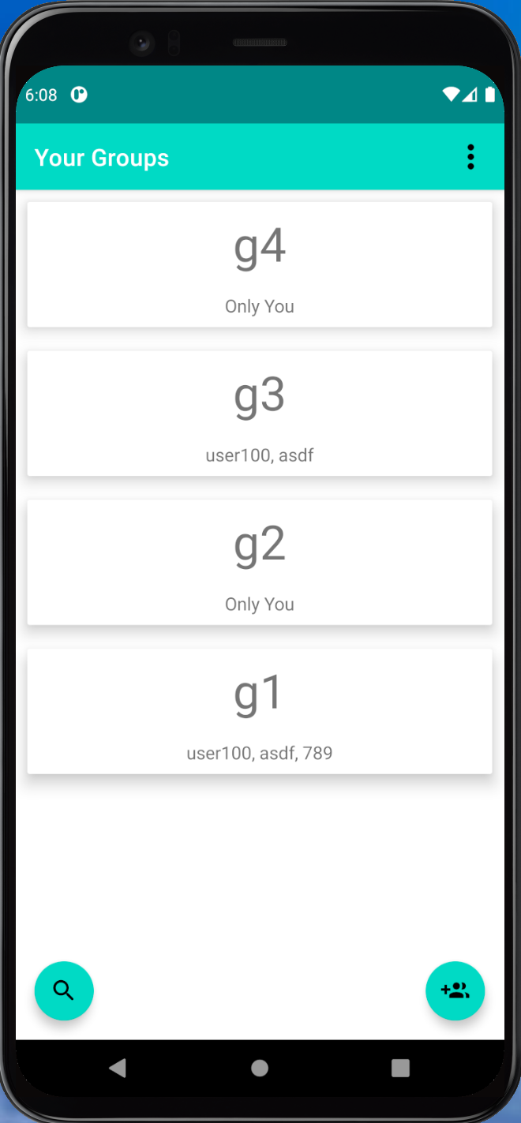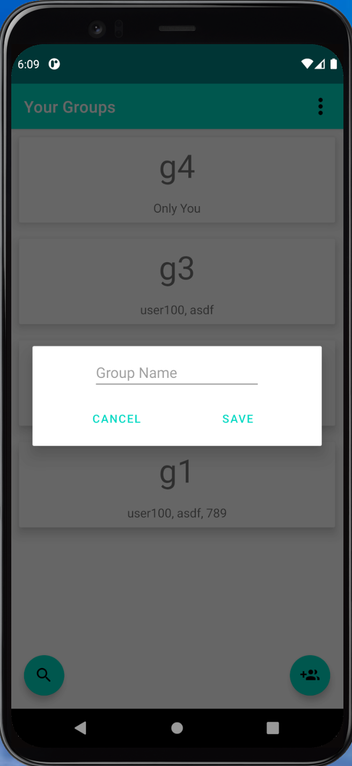

|  |  |
| --- | --- |
| EUC5: Create Group |  |
| ***Precondition:*** *This use case requires that the user is logged in to the ShareList App and is seeing the 'Create Group' activity.* | |
| Actor: User | System: ShareList App |
| 1. TUCBW user clicks on the ‘Create Group’ button.  3. The user fills in the text field and clicks the save button.  5. TUCEW the user sees a confirmation “The group has been added”. | 0. System displays the Create Group activity.  2. System displays text field to enter group name.  *4. System checks for errors and processes the save request. |
| ***Postcondition:*** *The group is created, stored in the database, and available to be acted upon immediately.* | |

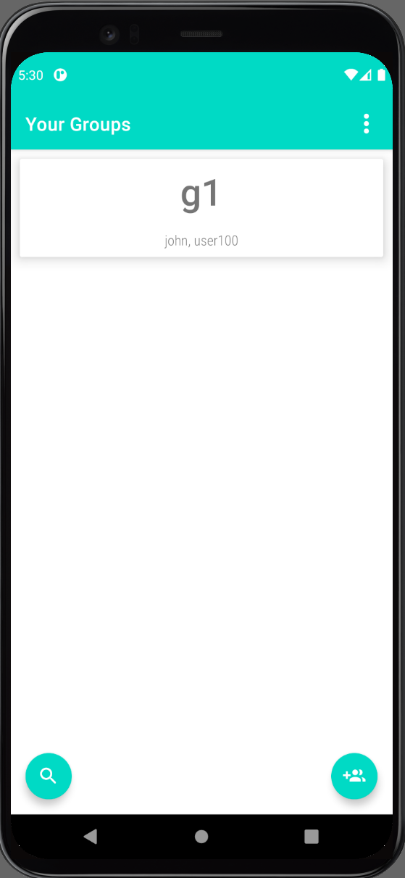

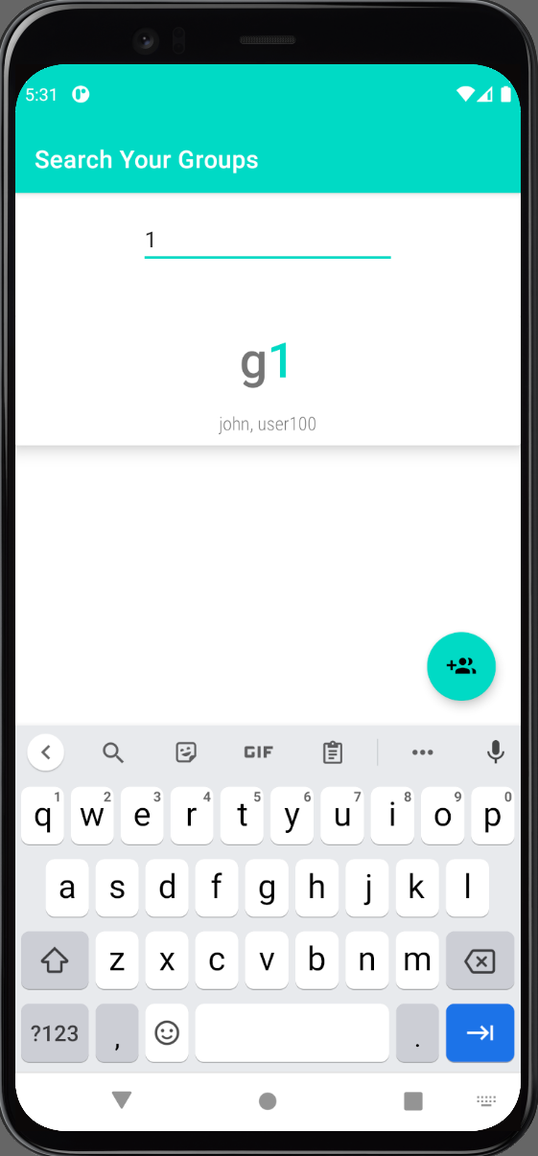

|  |  |
| --- | --- |
| EUC6: Search by Keywords |  |
| ***Precondition:*** *This use case requires that the user is logged into the app.* | |
| Actor: User | System: ShareList App |
| 1. TUCBW user clicks on the Search button and enters the search keyword.  3. TUCEW user sees the correct search results. | 0. System displays the Search button.  2. System displays search the result to the user |
| ***Postcondition:*** *The search result is available to be acted upon.* | |



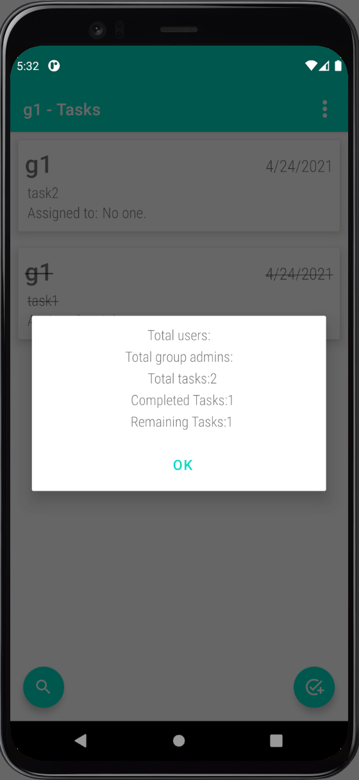

|  |  |
| --- | --- |
| EUC7: Generate Summary |  |
| ***Precondition:*** *This use case requires that the user is logged in and is a member of the particular group.* | |
| Actor: User | System: ShareList App |
| 1. TUCBW user clicks on the ‘Group Info’ button.  3. TUCEW the summary of group is displayed to the user. | 0. System displays the ‘Group Info’ button.  2. System displays the summary of the tasks. |
| ***Postcondition:*** *The Summary of the group is displayed to the user.* | |